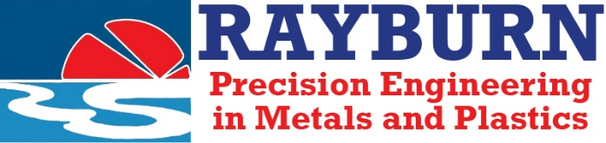**Rayburn Plastics Limited**

**Whitehouse Street**

**Walsall**

**West Midlands**

**WS2 8HR**

**T: 01922 625572**

**F: 01922 723333**

**www.rayburn.co.uk**

**ENVIRONMENTAL POLICY STATEMENT**

Rayburn Plastics Limited recognises that all industrial processes have the potential to cause environmental harm and we accept our environmental responsibility to society and future generations.

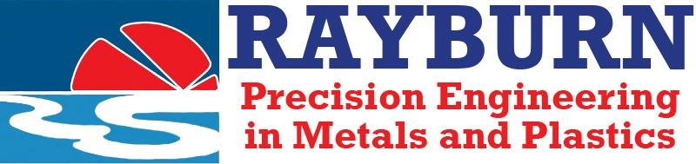Management’s aim, in addition to providing for compliance with all relevant regulatory requirements regarding the environment, is to achieve reasonable continuous improvement of environmental performance with a view to reducing the Company’s environmental impact.

**IN THIS RESPECT OUR POLICY IS TO:**

* Comply with current legislation and where practical seek to meet future legislative requirements or any other requirements ahead of relevant deadlines.
* Integrate environmental objectives into relevant business decisions in a cost-efficient manner.
* Require all colleagues to address environmental responsibilities, within the framework of normal operating procedures.
* Minimise waste, also seek to recover as much as is economically practical and ensure the remainder is disposed of responsibly.
* Our commitment is also addressed to the social responsibilities of Health & Safety (including risk prevention) and the principle of Equal Opportunity for all.

John Griffiths

J.A. Griffiths - Managing Director.

**January 2025 Review Date: January 2026**